To: Teresa Wall, Vice President of Research, Power-by-Nano Technologies

From: Team #13 (Section 038)

RE: Characterization of Semiconducting Quantum Dots

Date: January 24th, 2015

Our team has analyzed your requests pertaining to the characterization of semiconducting quantum dots. Based on your requests we have determined the largest quantum dot radius that yields 95% of the band gap energy of the bulk material and the optimum material and quantum dot radius for the absorption of red light (650 nm).

To find the largest nanoparticle radius our team calculated the band gap energy for 45,000 radii between 0.5nm and 5nm. We then compared these results against bulk material band gap energy. This yielded a result of 0.768 nm while remaining within the desired band gap energy.

Below is the plot of the band gap energy of the two nanoparticle systems as a function of nanoparticle radius, comparing materials 1 and 2:

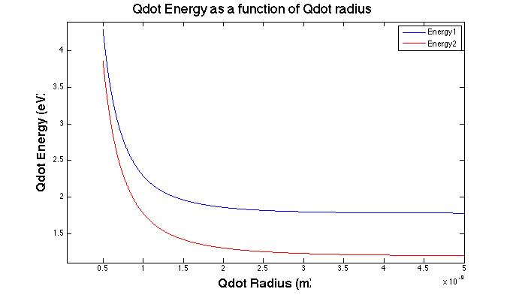

Based on this, our team believes that the nanoparticle band gap approaches that of the bulk material band gap when the radius for material 1 is 2.935 nm and for material 2 is 4.468 nm.

For use in the presence of red light, our team recommends material 1 at radius of 1.699 nm because the band gap energy at that radius most closely matches the energy of red light. Material 1 does this at a larger radius than material 2 and therefore is easier to manufacture.

Thank you for the opportunity to respond to your requests.

Sincerely,

Team #13